Introduced by Council Member Boyer and Co-Sponsored by Council Members Ferraro and Crescimbeni:

ORDINANCE 2019-462
AN ORDINANCE AMENDING chapter 656 (ZONINg CODE), ordinance code; amending Part 6 (off-street parking, on-street parking and loading regulations), subpart a (off-street parking, on-street parking and loading for motor vehicles), SECTION 656.607 (DESIGN STANDARDS FOR OFF-STREET, ON-STREET PARKING AND LOADING FACILITIES); AND AMENDING PART 12 (LANDSCAPE AND TREE PROTECTION REGULATIONS), SUBPART C (LANDSCAPING REQUIREMENTS), SECTIONS 656.1203 (DEFINITIONS), 656.1209 (APPLICABILITY), 656.1210 (LANDSCAPING REQUIREMENTS RELATED TO COMPREHENSIVE PLAN POLICIES), 656.1214 (VEHICULAR USE AREA INTERIOR LANDSCAPING), 656.1215 (PERIMETER LANDSCAPING), 656.1216 (BUFFER STANDARDS RELATING TO UNCOMPLEMENTARY LAND USES AND ZONING) AND 656.1222 (BUFFER REQUIREMENTS FOR RESIDENTIAL SUBDIVISIONS), ORDINANCE CODE, to create standardized buffers bASED ON differing ADJACENT uses; PROVIDING FOR A DIRECTIVE TO THE CODIFIERS; PROVIDING FOR ENFORCEMENT DATES; PROVIDING AN EFFECTIVE DATE.

BE IT ORDAINED by the Council of the City of Jacksonville:
Section 1. Amending Section 656.607 (Design Standards For Off-Street, On-Street Parking And Loading Facilities), SUBPART A (OFF-STREET PARKING, ON-STREET PARKING AND LOADING FOR MOTOR VEHICLES), PART 6, (OFF-STREET PARKING, ON-STREET PARKING AND LOADING REGULATIONS), Chapter 656 (ZONING CODE), Ordinance Code. Chapter 656 (ZONING CODE), PART 6, (OFF-STREET PARKING, ON-STREET PARKING AND LOADING REGULATIONS), SUBPART A (OFF-STREET PARKING, ON-STREET PARKING AND LOADING FOR MOTOR VEHICLES), Section 656.607 (Design standards for off-street, on-street parking and loading facilities) Ordinance Code, is hereby amended to read as follows:
Chapter 656 - ZONING CODE
* * *
PART 6. – (OFF-STREET PARKING, ON-STREET PARKING AND LOADING REGULATIONS)
* * *
SUBPART A. – OFF-STREET PARKING, ON-STREET PARKING AND LOADING FOR MOTOR VEHICLES
* * *
Sec. 656.607. - Design standards for off-street, on-street parking and loading facilities.
* * *
(d) Parking Reductions: The following parking reductions are available except for those uses described in Sections 656.604(e)(1) and 656.604(f)(1). the following uses: professional and business offices, including medical and dental offices or clinics; and business, commercial or personal service establishments.
(1) Tree protection offset. The required number of off-street parking spaces may be reduced by the Chief up to 20 percent if that area which would normally be required for parking is utilized for tree protection or landscaping in addition to that required by Part 12 (Landscape and Tree Protection Regulations).
* * *
(e) Access.
(1) Off-street parking and loading spaces shall be identified as to purpose and location when such is not clearly evidenced. Required off-street parking areas for three or more automobiles shall have individual spaces marked and shall be so designed, maintained and regulated that no parking or maneuvering incidental to parking shall be on a public or private street or sidewalk and so that an automobile may be parked and unparked without moving another. Each off-street parking or loading space shall be directly accessible from a street without crossing or entering another required off-street parking or loading space. However, off-street parking for townhouses or rowhouses permitted pursuant to Section 656.415 may be arranged to permit stacking or one required space behind another, if necessary. Spaces shall be arranged for convenient access and safety of pedestrians and vehicles. Each loading space shall be accessible from the interior of the building it serves and shall be arranged for convenient and safe egress and ingress by motor truck and/or trailer combination.
(2) Driveways to streets: The maximum width of any driveway not containing a landscaped island through the perimeter landscape area shall be 36 feet. The maximum width of any driveway containing a landscaped island through the perimeter landscape area shall be 48 feet and the driveway shall contain a landscaped island which measures not less than eight feet in width (from back of curb to back of curb) and 18 feet in length, surrounded by a six inch continuous raised curb, or other alternative approved by the Chief. The maximum combined width of all driveways through the perimeter landscape area shall be no more than 48 feet for properties with 100 feet or less of street frontage. For properties with more than 100 feet of street frontage, an additional one foot of driveway through the perimeter landscape area may be constructed for each four feet of street frontage in excess of 100 feet. In no event shall more than 50 percent of any street frontage be paved, nor shall the provisions of this Section be applied to reduce the permitted driveway width to less than 24 feet.
(3) Driveways to adjoining lots: Driveways may be permitted by the Chief to adjoining lots of compatible use. The maximum number of driveways which may be allowed shall be determined by first calculating the total length of the Project boundary VUA buffer adjacent to property lines, less the portion of the VUA separated from the common property line by a building and less the portion of the Project boundary VUA buffer separated from the use by a jurisdictional wetland or waterbody, and then applying the following criteria:
Net Length of  Project boundary VUA buffer | Maximum Number  of Driveways
50—149 feet | 2
150—299 feet | 3
300—599 feet | 4
For each additional 500 feet | 1 additional driveway

The maximum width of any driveway to an adjacent lot shall be 24 feet. The area of the continuous Project boundary buffer normally required where each driveway occurs shall be incorporated into the required Project boundary buffer landscape area to each side of the driveway.
(4) If a joint driveway easement is provided between adjacent properties, then the required Project boundary VUA buffer landscaping for each property shall be provided between the drive and any other vehicular use areas. That portion of the drive on each property shall be counted as part of the VUA of each property.
(f) Maintenance/drainage. Off-street parking and loading facilities shall be:
* * *
(i) Buffers. A six-foot visual barrier, not less than 95 percent opaque, shall be erected along the edges or portions or parking lots for nonresidential areas adjoining land in residential districts, unless releases authorizing the Chief to waive this requirement are secured from all adjoining property owners.
(j) Landscaping. Off-street parking and loading areas shall be landscaped in accordance with the requirements of Part 12 (Landscape and Tree Protection Regulations) and those uses described in Sections 656.604(e)(1) and 656.604(f)(1) shall meet or exceed the landscaping requirements contained within the Parking Lot Landscaping Matrix, Figure B attached.
* * *
(l) Landscaping. Off-street parking and loading areas shall be landscaped in accordance with the requirements of Part 12 (Landscape and Tree Protection Regulations) and shall meet or exceed the landscaping requirements contained within the Parking Lot Landscaping Matrix, Figure B attached. Required pervious parking area.
(1) Uses that are required to provide 4 spaces per 1,000 square feet of gross floor area shall provide a minimum of 10% of pervious parking on-site.
(2) Uses that are required to provide 5 spaces per 1,000 square feet of gross floor area shall provide a minimum of 15% of pervious parking on-site.
(3) Uses that are required to provide 4 spaces per 1,000 square feet of gross floor area shall provide a minimum of 20% of pervious parking on-site.

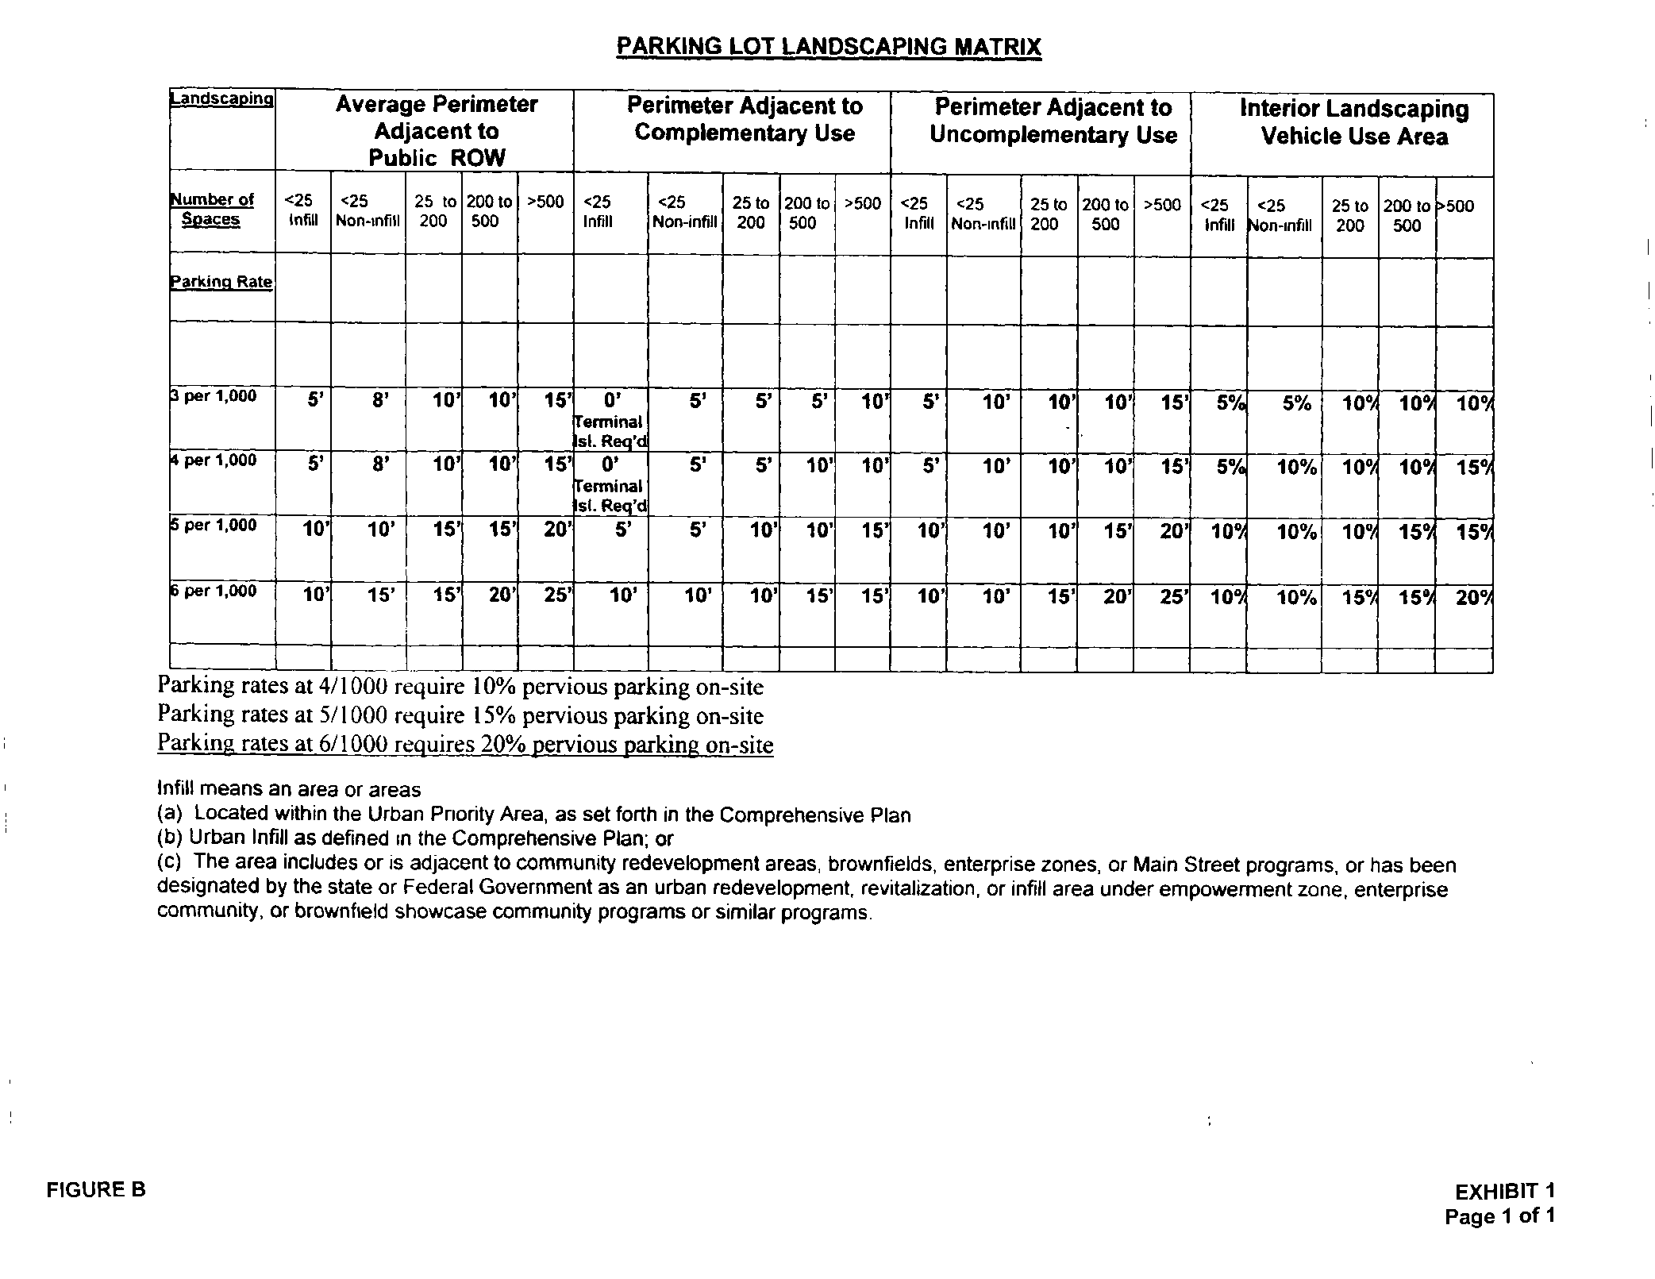
* * *
PART 12. – LANDSCAPE AND TREE PROTECTION REGULATIONS
* * *
SUBPART A. – GENERAL PROVISIONS
* * *
Sec. 656.1203. - Definitions.
For purposes of this Part, in addition to the following terms or words, the definitions provided for in Part 16 shall apply. If the definitions contained in this Section at any time conflict with the definitions contained in Part 16, the more restrictive definition(s) shall apply. As used in this Part:
Adjacent lot, property, or parcel means lands abutting and immediately next to, including parcels separated by a public or private right-of-way less than 50 feet in width, or developed parcels within 20 feet separated by a vacant strip.
(a) Annual consumptive use means the yearly amount of water applied to the landscape.
(b) Automatic controller means a mechanical or electronic timer, capable of operating valve stations to set the days and length of time of a water application.
(c) Bona-fide agricultural purposes means the use of land for bona fide agricultural purposes as described in F.S. § 193.461, provided the land is classified for assessment purposes by the property appraiser as "agricultural", pursuant to F.S. Ch. 193.
(d) Buffer yard or strip means a strip of land, identified on a site plan or by zoning ordinance requirement, established to protect one type of land use from another land use that may be incompatible. The area is landscaped, maintained and kept in open space.
(e) Caliper means the trunk diameter of planted trees. Caliper shall be measured six inches above the ground for trees up to and including four inches in caliper, and measured 12 inches above the ground for trees exceeding four inches in caliper. If the tree has a very enlarged irregular base, then the caliper measurement shall be taken up where the trunk has a more regular circumference, but in no case higher than four and one-half feet above the ground. If the tree forks between ground level and one foot above ground level, then the tree shall be considered a multi-trunked tree. Caliper for multi-trunked trees shall be determined by measuring each trunk immediately above the fork and adding the total caliper of the four largest trunks. (See also and compare definition of DBH in subsection (nn) of this Section.)
(f) Cultivated landscape area means planted areas that are frequently maintained by mowing, irrigating, pruning, fertilizing, etc.
(g) Development means any proposed material change in the use or character of the land, including, but not limited to, land clearing associated with new construction, the placement of any structure or site improvement on the land, or expansion of existing buildings.
(h) Drip line means a vertical line extending from the outermost branches of a tree to the ground.
(i) Ecosystem means a characteristic assemblage of plant and animal life with a specific physical environment, and all interactions among species and between species and their environment.
(j) Emitter devices means devices which are used to control the applications of irrigation water. This term is primarily used to refer to the low flow rate devices used in microirrigation systems.
Finished masonry wall means
(1) stone, brick or tile laid up unit by unit and set in mortar;
(2) stucco (exterior Portland cement plaster with 3 coats over metal lath or wire fabric lath);
(3) cultured stone or cast stone;
(4) architecturally finished block (i.e. burnished block, split faced concrete masonry units or architecturally finished tilt wall); or
(5) cementitious coating over foam core or like material.

(k) Ground cover means a low-growing herbaceous or woody plant other than turf, not over two feet high, used to cover the ground.
(l) Hedge means a landscape barrier consisting of a continuous, dense planting of shrubs.
Infill Project means, for purposes of Section 656.1216 (Buffer standards relating to adjacent uses), a project that meets all of the following criteria:
(1) is located in a built up area that is currently supported by infrastructure, utilities, and public facilities;
(2) is a maximum of 2 acres in size;
(3) is within the I-295 beltway;
(4) does not require a rezoning for the proposed project; and
(5) meets the criteria in either (a) or (b), below.
(a) The site is vacant (no improvements), and has been vacant for at least 12 months; and
(i) is within the Urban Priority Area or the Urban Area as defined in the Comprehensive Plan; or
(ii) is located on an Arterial or higher functionally classified roadway.
(b) The project is a redevelopment of improved land, of the same type and scale of the adjacent or nearby properties or developments.
(m) Infiltration rate means the rate of water entry into the soil expressed as a depth of water per unit of time (inches per hour).
(n) Irrigation system means a permanent, artificial watering system designed to transport and distribute water to plants.
Landscape buffer, or Adjacent Use Buffer, means the depth of land required to protect one type of use from another use, relating to the requirements between uses of Section 656.1216..
Landscape screen means plant material, fences, walls, berms, etc. that are placed within either a landscape buffer or a landscape strip for the purpose of screening one use from another.
Landscape strip means the area of land required around a Vehicular Use Area, relating to the requirements in Section 656.1215.
(o) Landscaped area means the entire parcel less the building footprint, driveway, nonirrigated portions of parking lots, hardscapes such as decks and patios, and other nonporous areas. Water features are included in the calculation of the landscaped area.
(p) Landscaping means any combination of living plants (such as grass, groundcover, shrubs, vines, hedges, or trees) and nonliving landscape material (such as rocks, pebbles, sand, mulch, walls or fences).
(q) Microirrigation (low volume) means the frequent application of small quantities of water directly on or below the soil surface, usually as discrete drops, tiny streams, or miniature sprays through emitters placed along the water delivery pipes (laterals). Microirrigation encompasses a number of methods or concepts including drip, subsurface bubbler, and spray irrigation.
(r) Mulch means nonliving organic materials customarily used in landscape design to retard erosion and retain moisture.
(s) Native vegetation. See Vegetation, native.
(t) Naturally occurring existing plant communities. See Vegetation, native.
(u) Open space means all areas of natural plant communities or areas replanted with vegetation after construction, such as revegetated natural areas; tree, shrub, hedge or ground cover planting areas; and lawns, and all other areas required to be provided as natural ground and landscaping pursuant to the Zoning Code.
(v) Perimeter landscape means a continuous area of land which is required to be set aside along the perimeter of a lot in which landscaping is used to provide a transition between and to reduce the environmental, aesthetic and other impacts of one type of land use upon another.
(w) Pervious paving materials means a porous asphaltic or concrete surface and a high-void aggregate base which allows for rapid infiltration and temporary storage of rain on, or runoff delivered to, paved surfaces.
(x) Plant community means a natural association of plants that are dominated by one or more prominent species, or a characteristic physical attribute.
(y) Preserve areas means vegetative areas required to be preserved under the jurisdiction of the Florida Department of Environmental Regulation, St. Johns River Water Management District and/or the United States Army Corps of Engineers or other regulatory agencies.
(z) Reserved.
(aa) Runoff water means water from rainfall and irrigation systems which is not absorbed by the soil or landscape to which it is applied and flows from the area, often contaminated with pesticides, fertilizers, and other pollutants.
(bb) Protected tree includes all of the following:
(1) Private protected tree means any tree with a DBH of six inches or more located on any lot within 20 feet of a street right-of-way (including an approved private street or other access easement) or a tree with a DBH of eight inches or more located within ten feet of any other property line, or a tree with a DBH of 11.5 inches or more located elsewhere on the lot.
(2) Public protected tree means any tree located on lands owned by the City, or other governmental agencies or authorities, or any land upon which easements are imposed for the benefit of the City, or other governmental agencies or authorities, or upon which other ownership control may be exerted by the City, or other governmental agencies or authorities, including rights-of-way, parks, public areas and easements for drainage, sewer, water and other public utilities, with:
- A DBH of six inches or more located within a City or other governmental right-of-way, or
(ii) A DBH of six inches or more and located on any lot within 20 feet of a street right-of-way, or
(iii) A DBH of eight inches or more located on any lot within ten feet of any other property line, or
(iv) A DBH of 11.5 inches or more located elsewhere on the lot.
(3) Exceptional specimen tree means any hardwood tree with a DBH of 24 inches or greater.
(cc) Scenic and historic corridors means any street right-of-way, including approved private streets, which is so designated by the Council, pursuant to the procedures hereinafter established and adopted by Council, as a result of its special historic, architectural, archaeological, aesthetic or cultural interest and value to the citizens of Jacksonville. The Chief shall maintain a list which specifies the location and boundaries of all corridors so designated.
(dd) Shrub means a an evergreen self-supporting woody perennial plant characterized by multiple stems and branches continuous from the base naturally growing to a mature height between two and 12 feet.
Shrub, Large means a shrub that reaches a mature height of 10-20 feet and a spread of 10-20 feet.
(ee) Site specific plant means a selection of plant material that is particularly well suited to withstand the physical growing conditions that are normal for a specific location.
(ff) Soil texture means the classification of soil based on the percentage of sand, silt, and clay in the soil.
(gg) Tree means a self-supporting woody plant having a single trunk or a multi-trunk of lower branches, growing to a mature height of at least 12 feet in northeast Florida.
(hh) Tree palm means an evergreen plant of the Palmaceae family cold hardy in northeast Florida having a single trunk and terminal crown of large pinnate or fan-shaped leaves.
(ii) Turfgrass means continuous plant coverage consisting of grass species suited to growth in the City of Jacksonville.
(jj) Understory means assemblages of natural low-level woody, herbaceous, and ground cover species which exist in the area below the canopy of the trees.
(kk) Vegetation, native means any plant species with a geographic distribution indigenous to all or part of the State of Florida.
Vehicular Use Area (VUA) means impervious or pervious surfaces used for off-street parking, storage, circulation, and loading/unloading of motor vehicles on private or public property, except parking garages.
Vehicular Use Area, Generally Open to the Public means Vehicular Use Areas, including visitor and employee parking in all uses, with the exception of single family dwellings and Specialized Vehicular Use Areas. However, visitor and employee parking for all uses, except single family is included in this category.
Vehicular Use Area, Specialized means Vehicular Use Areas generally closed to the public including motor vehicle repair facilities, bus, truck, railroad and other transportation terminals, outdoor storage facilities for motor vehicles, construction equipment, campers, trailers, and boats; freight terminals; warehouses; industrial facilities; and other similar uses. VUA’s used for visitor and employee off-street parking at these facilities is not included in this category.
(ll) Water use zone means a grouping of sprays, sprinklers, or microirrigation emitters so that they can be operated simultaneously by the control of one valve according to the water requirements of the plants used.
(mm) Florida-Friendly means a type of landscaping that maximizes the conservation of water by the use of site-appropriate plants - right plant in the right place methodology, efficient watering systems, appropriate fertilization, mulching, attraction of wildlife, responsible management of pests, recycling of yard waste, reduction of stormwater runoff ,and waterfront protection. The principles include planning and design, appropriate choice of plants, soil analysis, the use of solid waste compost, practical use of turf, efficient irrigation, appropriate use of mulches, and proper maintenance.
(nn) DBH (Diameter Breast Height) means the trunk diameter of an existing tree measured four and one-half feet above the average ground level at the tree base. If the tree forks between four and one-half and two feet above ground level, DBH is measured below the swell resulting from the fork. Trunks that fork below two feet, shall be considered multi-trunk trees. DBH for multi-trunk trees shall be determined by measuring each trunk immediately above the fork and adding the total diameters of the four largest trunks. (See also and compare definition for caliper in subsection (e) of this Section.)
(oo) Chief means the Chief as designated by the Director of the Planning and Development Department.
(pp) Shade tree means a species having a height at maturity of at least 45 feet and an average mature crown spread of no less than 30 feet, or trees having an average mature crown spread of less than 30 feet grouped so as to create a total average mature crown spread of no less than 30 feet.
(qq) Sensor Device means
(1) Rain sensor device - a low voltage electrical or mechanical component placed in the circuitry of an automatic turfgrass irrigation system which is designed to turn off a sprinkler controller when precipitation has reached a pre-set quantity.
(2) Soil Moisture sensor device - a low voltage electrical or mechanical component placed in the landscape of an automatic turfgrass irrigation system which is designed to suspend a sprinkler controller from operation when adequate soil moisture is present.
(3) Weather sensor device -a low voltage electrical or mechanical component placed in the circuitry, either directly or remotely, of an automatic turfgrass irrigation system which is designed to estimate plant water need and adjust a compatible sprinkler controller to apply the appropriate amount of supplemental irrigation.
(rr) Best Management Practices (BMP) means turf and landscape practices or a combination of practices, based on research, field testing, and expert review, determined to be most effective and practicable on-location means, including economic and technological considerations, for improving water quality, conserving water supplies and protecting natural resources.
(ss) Pressure Regulating Device means a device that maintains a constant flow and pressure for increased efficiency of irrigation systems. This device shall have a pressure regulating device built into the stem of head or provided in conjunction with the valve. If pressure regulation is derived through the head, it shall be identifiable from the top of the head.
(tt) Hardscape means areas such as patios, decks, driveways, in-ground swimming pools, paths and sidewalks that do not require irrigation.
(uu) As-Constructed Sketch means a legible drawing indicating the date of the irrigation system installation, the number of zones, locations of zones, backflow prevention devices, valves, emitter types and locations, controller(s), pressure regulating devices and sensor device(s). The drawing shall represent the irrigation system as it exists at the time of irrigation system completion and shall be prepared by or at the direction of the person installing the system.
(vv) Irrigation Zone means a grouping of rotors or sprinkler heads or pop-up sprays or micro irrigation emitters or other irrigation system equipment operated simultaneously by the control of one valve.
(ww) Low Maintenance Zone means an area a minimum of six feet wide adjacent to water courses which is planted and managed in order to minimize the need for fertilization, watering and mowing. See Chapter 366 Part 6 (Fertilizer Application), Ordinance Code.
(xx) Efficient Irrigation System means irrigation system design, installation, and maintenance that incorporate water efficient strategies and components, including, but not limited to, pressure regulation devices, sensor devices, correct head spacing, minimum areas of zones of matched precipitation rates and BMP.
(yy) Water Wise Principles means appropriate planning and design, proper choice of plants, soil analysis that may include the use of solid waste compost, efficient irrigation, practical use of turf, appropriate use of mulches, and proper maintenance consistent with Florida Statutes.
(Ord. 91-59-148, § 1; Ord. 93-718-395, § 1; Ord. 97-192-E, § 1; Ord. 1999-775-E, § 1; Ord. 2008-910-E, § 1; Ord. 2009-864-E, § 1)
* * *
PART 12. – (LANDSCAPE AND TREE PROTECTION REGULATIONS)
* * *
SUBPART C. – LANDSCAPING REQUIREMENTS
Sec. 656.1209. - Applicability.
(a) This Subpart shall be applicable to:
(1) all All new construction landscapes and irrigation systems for public agency projects and private development projects, including, but not limited to, industrial, commercial, recreational, multi-family residential developments and single family residential developments; that have not had a plat recorded and have not been accepted for maintenance by the City before April 4, 2011, or to
(2) the expansion or renovation of any existing development, building or use, including property in government use. Within any three-year period, when the total cumulative renovation of existing development is equal to at least 50 percent of the assessed value of the lot improvements on the start of the three-year period, according to the Property Appraiser, or that meets the following criteria:
(i) the total square footage of a structure or structures within a development is expanded to by 50 percent or greater, as well as including any cumulative footprint square footage expansions totaling 50 percent or greater,; or
(ii) the VUA is increased by 25%; or
(iii) there has been a discontinuance of use for a period of one year or more and no Request for a Renewal to Resume Conforming Use is made and granted. In order to be exempt from applicability, said Request shall be made on a form, and include information, as required by the Planning and Development Department to show that the proposed use is substantially the same as the previous conforming use, and will not increase impacts on the adjacent properties.
(iv) any expansion that extends into the Adjacent Use Buffer area required by this Part.
the project will be deemed a Qualified Project then this Subpart shall be applicable to existing development and the expansion. If the Qualified Project includes alterations to parking areas or exterior areas where landscaping improvements are required, the area where such project is planned shall also be brought into full compliance with this Subpart. For all other Qualified Projects, 20 percent of the project cost shall be applied to meet the requirements of this Subpart. If full compliance with this Subpart is not achieved through the improvements described herein, priority for improvements shall be given to areas that are visible from public rights-of-way and other public areas and improvements providing internal parking lot shade.
(b) All property used for right-of-way is specifically exempted from the provisions of this Subpart.
(c) No building permit shall be issued in violation of any of the provisions hereof.
(d) Landscape materials installed in addition to the minimum requirements of this Subpart, shall meet all criteria of this Subpart except for plant size and quantity. Property located in any single-family Residential District (RR, RLD, or single family residential portion of a PUD) and used as such or property used for agriculture or single-family residential in an Agriculture (AGR) district is excluded from the requirements of Sections 656.1214, 656.1215 and 656.1216. Owners of single family residences within residential subdivisions that have not had a plat recorded and have not been accepted for maintenance by the City before April 4, 2011 shall follow the Best Management Practices for Florida-Friendly landscape, Efficient Irrigation and Water Wise Principles, but shall have flexibility in meeting the requirements as set forth in this Subpart.
(e) There are three basic types of landscape buffers and screening that may be required for an applicable project. They include (1) Vehicular Use Area interior landscaping (Sec. 656.1214); (2) Vehicular Use Area perimeter landscaping and street buffers for residential subdivisions (Sec. 656.1215 and Sec. 656.1222); and (3) Buffer standards related to adjacent uses (Sec. 656.1216).
* * *
Sec. 656.1210. - Landscaping requirements related to Comprehensive Plan policies.
(a) Pursuant to Conservation/Coastal Management Element Policy 3.3.5, the The preservation of native habitat vegetation during land development activities is required, either through maintenance of natural vegetation on the project site, or through the planting of native vegetation. If through planting, at least 50 percent of all plantings incorporated in an approved landscape plan for any project site shall consist of native vegetation suitable to that site, and at least 60 percent of all post-development vegetation shall be indigenous to the City.
(b) All new developments shall provide for the conservation and preservation of environmentally sensitive lands, native plant communities and wildlife habitat to maintain the natural ecological types and sustainable populations of wildlife native to the City consistent with the provisions of Objective 3.3, Policy 2.3.7 and associated policies of the Conservation/Coastal Management Element of the Comprehensive Plan.
(c) All nonresidential land uses except in the CCBD District shall provide a minimum of ten percent of the lot in open space.
(d) All multiple-family dwellings of 100 dwelling units or more shall be required to provide 150 square feet of recreation open space per dwelling unit.
* * *
Sec. 656.1214. - Vehicular use area Use Area interior landscaping.
(a) Vehicular use areas open to the public:
(1) Except for those uses described in Sections 656.604(e)(1) and 656.604(f)(1) professional and business offices, including medical and dental offices or clinics, and business, commercial or personal service establishments, ten percent (10%) of vehicular use areas (VUA's) used for off-street parking, employee parking, auto service stations, outdoor retail display and sale of motor vehicles, service drives, and access drives within property located in multifamily, residential, commercial, industrial, and public facilities use zoning districts shall be landscaped.
(2) For those uses described in Sections 656.604(e)(1) and 656.604(f)(1) professional and business offices, including medical and dental offices or clinics, and business, commercial or personal service establishments, all vehicle use area VUA interior landscaping shall satisfy the requirements set forth in the Parking Lot Landscaping Matrix, Figure B, set forth in Section 656.607(j). In the event the landscaping required under this section exceeds the requirements set forth in the Parking Lot Landscaping Matrix, Figure B of Section 656.607(j), the requirements of this section shall be relaxed to the extent necessary to comply with the Parking Lot Landscaping Matrix. Meet the following landscape area percentage requirements:
(i) Infill projects with less than 25 required spaces: 5%;
(ii) non-Infill projects with less than 25 required spaces: 10%;
(iii) all other projects with greater than 25 required spaces: 10%.
For purposes of this VUA interior landscaping area requirement, “infill” means an area or areas that either: are located within the Urban Priority Area, as set forth in the then current Comprehensive Plan; meet the definition of “Urban Infill” as defined in the Comprehensive Plan; or, the area includes or is adjacent to community redevelopment areas, brownfields, enterprise zones, or Main Street programs, or have been designated by the state or Federal Government as an urban redevelopment, revitalization, or infill area under empowerment zone, enterprise community, or brownfield showcase community programs or similar programs.
* * *
Sec. 656.1215. – Vehicular Use Area perimeterPerimeter landscaping.
The VUA perimeter landscaping requirements consist of requirements of the VUA as it addresses the right-of-way, and requirements regarding the lengths of VUA that face adjacent properties. For VUAs that face adjacent properties, the proposed development may be complementary, or may be uncomplementary as defined below. VUA perimeter landscaping requirements are separate from the Adjacent Use Buffer requirements contained in Section 656.1216. They may overlap or be co-extensive, and in such case are not intended to be in addition to one another. In the case of overlap, the more stringent requirements shall apply. However, to the extent that the VUA is situated such that the VUA landscape strip, as required by this Section, and the Adjacent Use Buffer are not co-extensive, then the requirements of the VUA perimeter landscaping and the Adjacent Use Buffer requirements are in addition to one another. See Figure 1215 below.
Just as in Section 656.1214 (Vehicular Use Area interior landscaping), the uses of professional and business offices, including medical and dental office or clinics; and business, commercial or personal service establishments, are subject to separate VUA landscaping requirements. This does not extend to Section 656.1216 (Buffer standards relating to adjacent land uses and zoning), as that section contains a matrix as shown in Table 1216 for the requirement of the appropriate Adjacent Use Buffer.
(a) VUA perimeter Perimeter landscaping adjacent to streets: shall contain a landscape strip of the depth and other characteristics as stated below. For those uses described in Sections 656.604(e)(1) and 656.604(f)(1), all perimeter landscaping shall also satisfy the requirements set forth in the Parking Lot Landscaping Matrix, Figure B, set forth in Section 656.607(j). In the event the landscaping required under this section exceeds the requirements set forth in the Parking Lot Landscaping Matrix, Figure B of Section 656.607(j), the requirements of this section shall be relaxed to the extent necessary to comply with the Parking Lot Landscaping Matrix.
(1) For the uses of professional and business offices, including medical and dental office or clinics; and business, commercial or personal service establishments, all All VUA's which are not entirely screened by an intervening building from any abutting dedicated public street or approved private street, to the extent such areas are not so screened, shall contain the following:
(i) Infill Projects with less than 25 required spaces: an average 5 foot deep landscape strip.
(ii) Non-Infill Projects with less than 25 required spaces: an average 8 foot deep landscape strip.
(iii) Any project with greater than 25 but less than 501 required spaces: an average 10 foot deep landscape strip.
(iv) Any project with over 500 required spaces: an average 15 foot deep landscape strip.
For purposes of this VUA perimeter landscape strip depth requirement, “infill” means an area or areas that either: are located within the Urban priority Area, as set forth in the then current Comprehensive Plan; meet the definition of “Urban Infill” as defined in the Comprehensive Plan; or, the area includes or is adjacent to community redevelopment areas, brownfields, enterprise zones, or Main Street programs, or have been designated by the state or Federal Government as an urban redevelopment, revitalization, or infill area under empowerment zone, enterprise community, or brownfield showcase community programs or similar programs.
(12) Except for those uses described in Sections 656.604(e)(1) and 656.604(f)(1), a For uses other than professional and business offices, including medical and dental office or clinics; and business, commercial or personal service establishments, a landscaped area shall be provided of not less than ten square feet for each linear foot of VUA street frontage, 50 percent of which shall be at least a five-foot wide strip abutting the street right-of-way except for driveways. For those uses described in Sections 656.604(e)(1) and 656.604(f)(1), the landscape area is determined by the total number of parking spaces provided and the parking rate. All perimeter landscaping shall conform to Section 656.607(j), Parking Lot Landscaping Matrix, Figure B. Landscaped area calculations shall be met exclusive of any driveway width. The remaining required landscape area shall be located within 30 feet of the street right-of-way;
(23) A durable opaque landscape screen along at least 75 percent of the street frontage excluding driveways. Shrubs, walls, fences, earth mounds and preserved existing understory vegetation, or combination thereof, may be used so long as the screen is no less than three feet high measured from the property line grade two years after installation. Shrubs and preserved existing understory vegetation shall be evergreen, shall be initially a minimum of 18 inches in height and spaced so that 85 percent opacity is achieved within two years. Shrubs located within three feet of a directional sign as defined in Section 656.1302(e) are not required to meet the minimum height requirements of this subsection. Walls or fences shall be no more than four feet in height and of wood, brick or masonry at least 85 percent opaque. Earth mounds shall not exceed a slope of three to one. No less than 25 percent of street side frontage of walls or fences shall be landscaped with shrubs or vines;
(34) No less than one tree, located within 25 feet of the street right-of-way, for each 50 linear feet, or fraction thereof, of VUA street frontage. The trees may be clustered, but shall be no more than 75 feet apart. At least 50 percent of the trees shall be shade trees. If an overhead power line abuts the street frontage, then the required trees reaching a mature height greater than 25 feet shall be located at least 20 feet away from the power line;
(45) The remainder of the landscape area shall be landscaped with trees, shrubs, groundcovers, grass, or mulch, except that mulch shall not exceed 25 percent of the total landscape area;
(56) Landscape areas required by this Section shall not be used to satisfy the VUA interior landscape requirements. However, the gross area of the VUA perimeter landscaping which exceeds the minimum requirements may be used to satisfy the VUA interior landscape requirements of Sec. 656.1214;
(67) If a railroad or utility right-of-way separates the VUA from the public street or approved private street, the perimeter landscaping requirements of this Section shall still apply.
(b) VUA perimeter Perimeter landscaping required adjacent to complementary abutting properties: For those uses described in Sections 656.604(e)(1) and 656.604(f)(1), all perimeter landscaping shall also satisfy the requirements set forth in the Parking Lot Landscaping Matrix, Figure B, set forth in Section 656.607(j). In the event the landscaping required under this section exceeds the requirements set forth in the Parking Lot Landscaping Matrix, Figure B of Section 656.607(j), the requirements of this section shall be relaxed to the extent necessary to comply with the Parking Lot Landscaping Matrix.
(1) For the uses of professional and business offices, including medical and dental office or clinics; and business, commercial or personal service establishments, all VUA's which are not entirely screened by an intervening building from any adjacent property, to the extent such areas are not so screened, shall contain the following:
(i) Infill projects with less than 25 required spaces: no landscape strip is required;
(ii) Non-Infill projects with less than 25 required spaces: a 5 foot deep landscape strip
(iii) Any project with more than 25 required spaces and less than 501 required spaces: a 5 foot deep landscape strip.
(iv) Any project with over 500 required spaces: a 10 foot deep landscape strip.
(2) For uses other than professional and business offices, including medical and dental office or clinics; and business, commercial or personal service establishments, all All vehicular areas VUAs which are not entirely screened by an intervening building from an abutting property, to the extent such areas are not screened, shall contain the following:
(1i) A continuous landscape area at least five feet wide between the VUA's and the abutting property, landscaped with shrubs, groundcovers, preserved existing vegetation, mulch and grass.
(2ii) No less than one tree, located within 25 feet of the outside edge of the VUA, for every 50 linear feet, or fraction thereof, of the distance the VUA abuts the adjacent property. Trees may be clustered but shall be no more than 75 feet apart. At least one-half of the required number of trees shall be shade trees.
(3) A buffer wall between incompatible land uses as required by Section 656.1216, if applicable.
(4iii) If an alley separates the VUA from the abutting property, the perimeter landscaping requirements shall still apply.
(c3) Existing landscape screen: If an existing landscape screen has been established on abutting property, then it may be used to satisfy the requirements of this Section, so long as the existing landscape screen is abutting the common property line, and it meets all applicable standards of this Subpart.
(d) Driveways to streets: The maximum width of any driveway not containing a landscaped island through the perimeter landscape area shall be 36 feet. The maximum width of any driveway containing a landscaped island through the perimeter landscape area shall be 48 feet and the driveway shall contain a landscaped island which measures not less than eight feet in width (from back of curb to back of curb) and 18 feet in length, surrounded by a six inch continuous raised curb, or other alternative approved by the Chief. The maximum combined width of all driveways through the perimeter landscape area shall be no more than 48 feet for properties with 100 feet or less of street frontage. For properties with more than 100 feet of street frontage, an additional one foot of driveway through the perimeter landscape area may be constructed for each four feet of street frontage in excess of 100 feet. In no event shall more than 50 percent of any street frontage be paved, nor shall the provisions of this Section be applied to reduce the permitted driveway width to less than 24 feet.
(e) Driveways to adjoining lots: Driveways may be permitted by the Chief to adjoining lots of compatible use. The maximum number of driveways which may be allowed shall be determined by first calculating the total length of the VUA perimeter adjacent to property lines of compatible use, less the portion of the VUA separated from the common property line by a building and less the portion of the perimeter VUA separated from the compatible use by a jurisdictional wetland or waterbody and then applying the following criteria:
Net Length of  Perimeter VUA | Maximum Number  of Driveways
50—149 feet | 2
150—299 feet | 3
300—599 feet | 4
For each additional 500 feet | 1 additional driveway

The maximum width of any driveway to an adjacent lot shall be 24 feet. The area of the continuous five feet wide perimeter landscape strip normally required where each driveway occurs shall be incorporated into the required perimeter landscape area to each side of the driveway.
(f) If a joint driveway easement is provided between adjacent property, then the required perimeter landscaping for each property shall be provided between the drive and any other vehicular use areas. That portion of the drive on each property shall be counted as part of the VUA of each property.
Sec. 656.1216. - Buffer standards relating to uncomplementary land uses and zoning.
(c) VUA perimeter landscaping required adjacent to uncomplimentary properties.
(a1) Where uncomplementary land uses or zoning districts, as defined below, are adjacent to a VUA, without an intervening street50 foot, or wider, right-of-way, a buffer landscape strip shall be required along the perimeter of the VUA between the VUA and the common boundaries of the uses or zoning districts. Such landscape strip for the uses of professional and business offices, including medical and dental office or clinics; and business, commercial or personal service establishments, shall be as follows:
(i) Infill projects with less than 25 required spaces: a 5 foot deep landscape strip.
(ii) Non-Infill projects with less than 25 required spaces: a 10 foot deep landscape strip.
(iii) Any project with greater than 25, but less than 500 required spaces: a 10 foot deep landscape strip.
(iv) Any project with over 500 required spaces: a 15 foot deep landscape strip.
(2) Such buffer landscape strip for uses other than professional and business offices, including medical and dental office or clinics; and business, commercial or personal service establishments, shall be at least ten (10) feet in depth, except as set forth in the Parking Lot Landscaping Matrix, Figure B, set forth in Section 656.607(j), in width the entire length of all such common boundaries.
(3) The following shall constitute uncomplementary uses and zoning districts:
(1i) Multiple-family dwelling use or zoning districts (three or more attached units) when adjacent to single-family dwelling(s) or lands zoned for single-family dwellings.
(2ii) Office use or zoning districts, when adjacent to single-family or multiple-family dwellings, mobile home parks or subdivisions or lands zoned for single-family or multiple-family dwellings, mobile home parks or subdivisions.
(3iii) Mobile home park use or zoning districts, when adjacent to single-family dwellings, multiple-family dwellings and office uses, or lands zoned for single-family dwellings, multiple-family dwellings or offices.
(4iv) Commercial and institutional uses or zoning districts, when adjacent to single-family dwellings, multiple-family dwellings or mobile home parks or mobile home subdivision uses or lands zoned for single-family dwellings, multiple-family dwellings or mobile home parks or mobile home subdivision.
(5v) Industrial uses or zoning districts, when adjacent to any nonindustrial uses or zoning districts other than agricultural land uses or zoning districts.
(6vi) Utility sites such as transmission or relay towers, pumping stations, electrical sub-stations, telephone equipment huts or other similar uses when adjacent to single-family dwellings, multiple-family dwellings, mobile homes, offices, institutional uses or zoning districts or adjacent to public or approved private streets.
(7vii) On property zoned for government use, the proposed government use most similar to the land uses or zoning districts specified above shall determine the buffer standards.
(bd) Buffer Landscape strip material requirements shall be as follows:
(1) Tree count. The total tree count required within the buffer landscape strip shall be determined by using a ratio of one tree for each 25 linear feet of required buffer landscape strip, or majority portion thereof, with a minimum of 50 percent of the trees being shade trees. Trees shall be spaced so as to allow mature growth of the trees, but spaced no greater than 40 feet on center.
(2) Ground cover. Grass or other ground cover shall be planted on all areas of the buffer landscape strip required by this Section which are not occupied by other landscape material.
(3) Visual Landscape screen. A visual screen running the entire length of common boundaries shall be installed within the buffer landscape strip, except at permitted access ways. The visual screen may be a wood, wood composite, or masonry wall, PVC fence, landscaping, earth mounds or combination thereof so long as such strips shall provide at the time of installation a minimum of 85 percent opacity for that area between the finished grade level at the common boundary line and six feet above such level and horizontally along the length of all common boundaries. Plants or preserved vegetation shall be evergreen, a minimum of five feet tall at the time of installation, and spaced so that 85 percent opacity is achieved within two years. Earth mounds shall not exceed a slope of three to one. If a visual screen, which satisfies all applicable standards, exists on adjacent property abutting the property line or exists between the proposed development on the site and the common property line, then it may be used to satisfy the visual screen requirements. Except for industrial uses or ones, whenever a preserve area or water body at least 100 feet wide when measured perpendicular to the property line separates the uncomplementary uses, then the visual landscape screen height requirement shall be reduced to three feet and the buffer strip width shall be reduced to five feet, when measured from the top of the lake bank or the jurisdictional wetland edge. If a plant material is used for the visual landscape screen, it shall be a minimum height of 24 inches at the time of installation.
(4) Prevailing requirement. Whenever parcels of land fall subject to both the perimeter landscaping requirements and the uncomplementary land use buffer landscape strip requirements, the more stringent of the article, the latter requirements shall prevail.
(5) Hardship. If the Chief determines that the construction of a landscape buffer area required by this article would create a hardship for the existing structures or vehicular use areas VUAs, the Chief may approve a buffer landscape area with a width no less than five feet, provided such buffer landscape area meets the visual screening requirements of this article.
(ce) The buffer landscape strip shall not be used for principle or accessory uses and structures, vehicular use areas VUAs, dumpster pads, signs, equipment, storage. Slopes within buffer landscape strips shall not exceed four to one.
(df) If a water body exists along the common property line between uncomplementary uses which is less than 100 feet wide when measured perpendicular to the property line then the buffer strip shall be established between the use and the water body. Preserve areas may be used as buffer strips, so long as the tree and visual screen requirements can be satisfied.
(g) Existing landscape screen: If an existing landscape screen has been established on abutting property, then it may be used to satisfy the requirements of this Section, so long as the existing landscape screen is abutting the common property line, and it meets all applicable standards of this Subpart.
Section 656.1216 – Buffer standards relating to adjacent uses.
Buffers and landscaping between adjacent uses (“Adjacent Use Buffer”) shall be provided according to the Buffer Type as noted on the Buffer Table shown below in Table 1216. Adjacent Use Buffers are separate requirements from the VUA perimeter landscape strips, but may be co-extensive with the VUA perimeter landscape strips, and may be used to satisfy both the VUA perimeter landscaping requirement and this Adjacent Use Buffer requirement if located in a co-extensive area. The more stringent requirements shall apply. Likewise, if other provisions of the Ordinance Code prescribe a buffer between uses, the more stringent requirement shall apply.
In Table 1216, the “Proposed use/zoning” is listed on the vertical, left-hand column of the Table. The existing use, or current zoning if vacant, is listed on the horizontal, top row of the Table. If the existing use is nonconforming, then the property shall be deemed vacant and buffered accordingly. Notwithstanding, if the adjacent property is developed solely with a nonconforming residential use, the Adjacent Use Buffer requirement shall be determined based on the residential use. Adjacent Use Buffer areas may not be located on any portion of an existing or dedicated street right-of-way or roadway easement.
If the Proposed use/zoning is more intense than the use to which it will be adjacent, the Buffer Type required is shown on the “bottom half” of the Table below the dark shaded boxes that create a diagonal “line” from the top left-hand corner of the Table extending to the bottom right-hand corner of the Table. In the case of an existing use expansion that is more intense than the adjacent use, where no Buffer currently exists, the existing use may place the fence or wall on the property line.
If the Proposed use/zoning is less intense than the use to which it will be adjacent, the Adjacent Use Buffer Type required is shown on the “top half” of the Table. In this case, a ½ will appear immediately preceding the designated Adjacent Use Buffer Type, if any, which reduces the Adjacent Use Buffer requirement as indicated below. Additionally, there is no buffer required if the adjacent, more intense property is already developed with a use conforming to its zoning district. The fence or wall may be reversed and located on the property line.

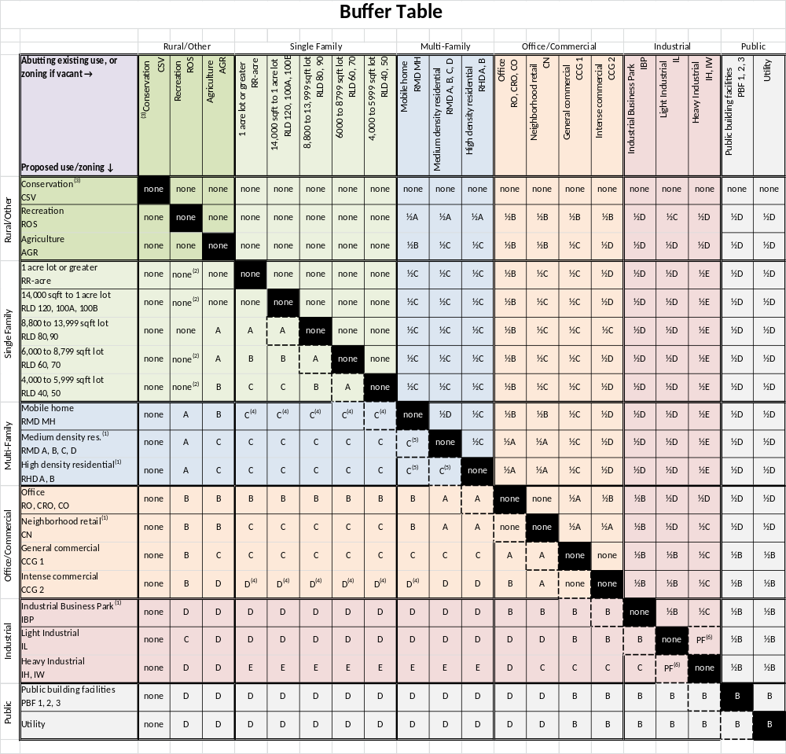
Table 1216

There are 5 Adjacent Use Buffer Types (“Buffer Types”), designated according to the letter A, B, C, D, or E. The Buffer Types are graphically shown in Figures 1216-A through 1216-E. The following screening standards are per 100 feet of length of VUA, or fraction thereof, per Buffer Type:
(a) Adjacent Use Buffer Type A:
(1) 15 feet in depth, 5 Medium Evergreen trees and 18 large scale 5 gallon shrubs; or
(2) 10 feet in depth, 5 Medium Evergreen trees, 6 large scale 5 gallon shrubs, and a 6 foot height privacy fence; or
(3) 10 feet in depth, 4 Medium Evergreen trees, and a 6 foot height finished masonry wall.
(4) A “½” designation requires only ½ of the Buffer width, and no trees. Shrubs are still required.
(b) Adjacent Use Buffer Type B:
(1) 20 feet in depth, 2 large trees, 6 Medium Evergreen trees and 30 large scale 7 gallon shrubs; or
(2) 15 foot in depth, 5 Medium Evergreen trees, 11 large scale 3 gallon shrubs, and a 6 foot height privacy fence; or
(3) 15 feet in depth, 4 Medium Evergreen trees, and a 6 foot height finished masonry wall.
(4) A “½” designation requires only ½ of the Buffer width, and no trees. Shrubs are still required.
(c) Adjacent Use Buffer Type C:
(1) 25 feet in depth, 3 Large trees, 5 Medium Evergreen trees, and 30 large scale 7 gallon shrubs; or
(2) 20 feet in depth, 3 Large trees, 5 Medium Evergreen trees and 11 large scale 3 gallon shrubs, and a 6 foot height privacy fence; or
(3) 20 feet in depth, 2 Large trees, 4 Medium evergreen trees, and a 6 foot height finished masonry wall.
(4) A “½” designation requires only ½ of the trees and ½ of the shrubs, and the fence or wall, if that option is selected, may be on the property line.
(d) Adjacent use Buffer Type D:
(1) 30 feet in depth, 4 Large trees, 5 Medium Evergreen trees, and 30 large scale shrubs; or
(2) 25 feet in depth, 4 Large trees, 5 Medium Evergreen trees, and a 6 foot height privacy fence or wall.
(3) A “½” designation requires only ½ of the trees and ½ of the shrubs, and the fence or wall, if that option is selected, may be on the property line.
(e) Adjacent Use Buffer Type E: 30 feet in depth, 3 Large trees, 7 Medium Evergreen trees, 18 large scale 7 gallon shrubs, and an 8 foot height finished masonry wall. A “½” designation requires only ½ of the trees and ½ of the shrubs, and the fence or wall may be on the property line.

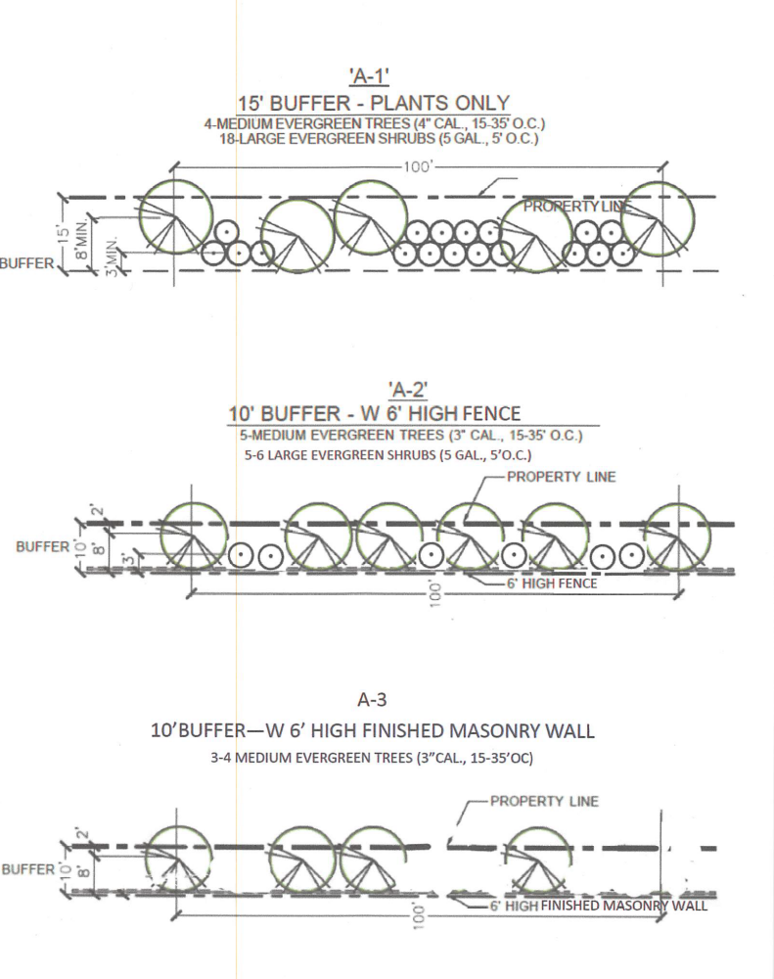
FIGURE 1216-A
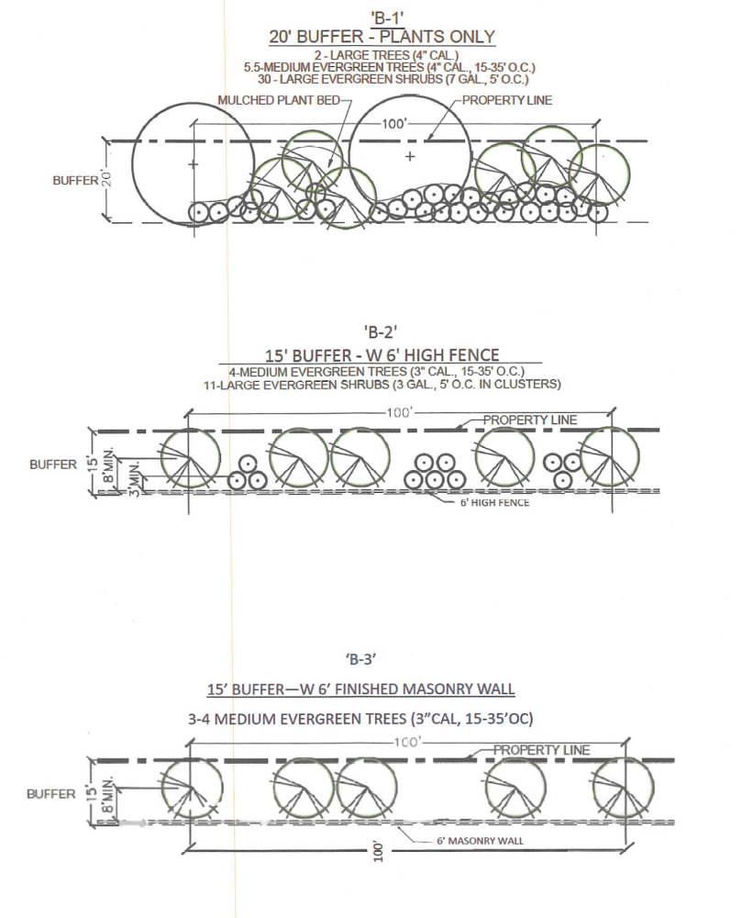
FIGURE 1216 – B

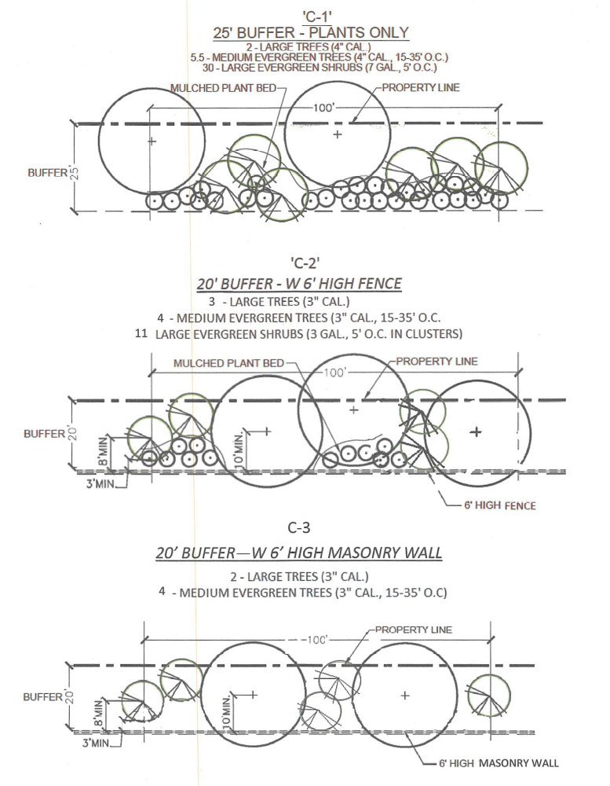

FIGURE 1216 – C
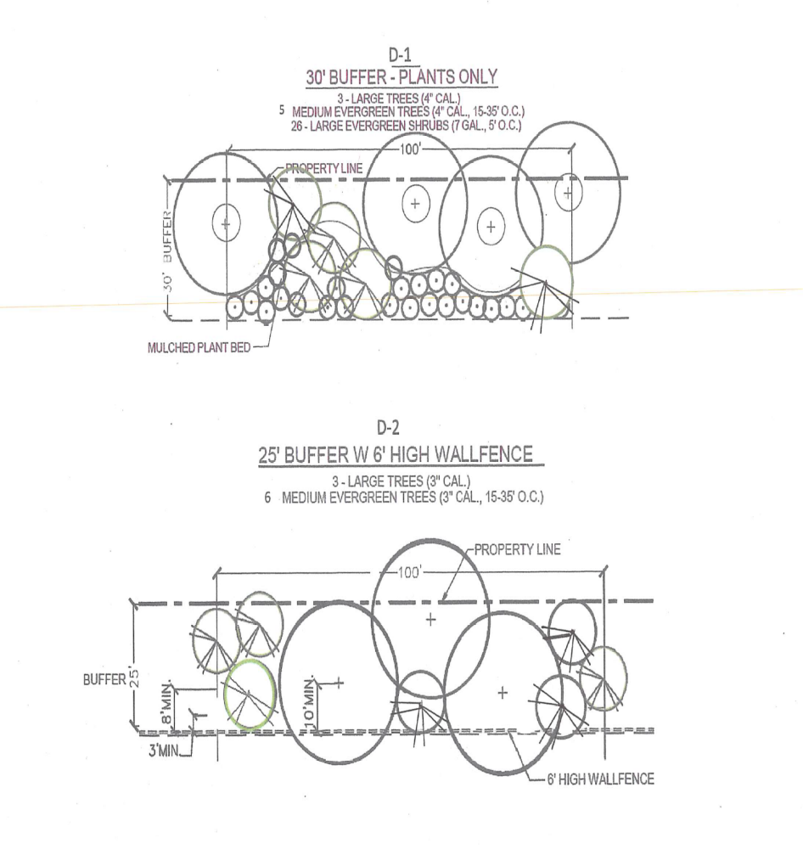

FIGURE 1216 - D
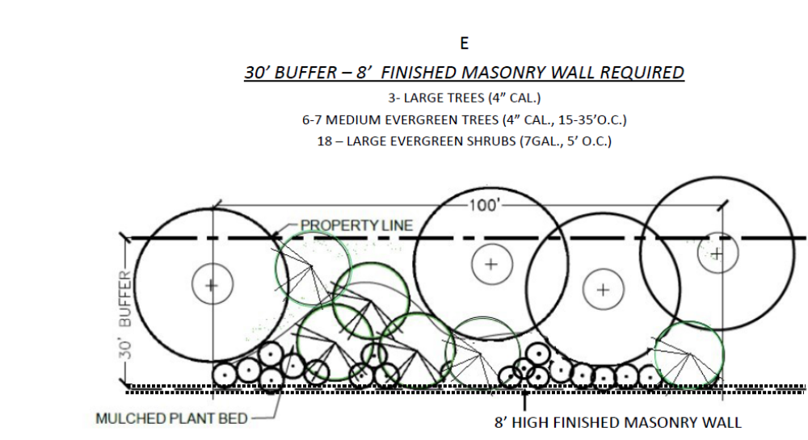
FIGURE 1216 - E

(f) The following additional parameters apply, and are shown as their numerical designation on Table 1216. For example, the number “(1)” is shown on the column next to “Medium density residential (RMD-A, B, C, D),” “High density residential (RHD-A,B),” “Neighborhood retail (CN),” and “Industrial Business Park (IBP).” This indicates that the parameter stated in number (1), below, applies to these zoning districts, and no others. Thus, where a number is indicated on Table 1216 next to a Proposed use/zoning, it pertains to the following:
(1) “(1)” If the building height is limited to thirty-five feet, then RLD 40-50 Adjacent Use Buffers may be used.
(2) “(2)” Single family residential locating adjacent to a recreational use will require the single family use to provide a 4 foot height fence.
(3) “(3)” The following list of conservation sites are to be treated as AGR from a buffering standpoint:
Castaway Island Preserve
Dutton Island Preserve (expansion)
Huguenot Memorial Park
Little Talbot State Park
Big Talbot State Park
Timucuan Ecological and Historic Preserve (NPS)
Timucuan Ecological and Historic Preserve (NFLT)]
Timucuan Ecological and Historic Preserve (JaxPort)
Timucuan Ecological and Historic Preserve (COJ)
Cedar Point Preserve (COJ)
Cedar Point Preserve (NPS)]
Pumpkin Hill State Buffer Park (FLA)
Betz-Tiger Point Preserve
Seaton Creek Preserve (COJ)
Thomas Creek Preserve (SJRWMD)
Thomas Creek Preserve (COJ)
Baldwin Rail Trail (COJ)
Otis Road Trailhead and adjacent property (COJ)
Cary State Forest (DOF)
Camp Milton Historic Preserve (COJ)
Camp Milton Historic Preserve reenactment grounds
Bulls Bay Preserve
Cecil Conservation Corridor
Sal Taylor Creek Preserve
McGirts Creek Park and Preserve
Julington Durbin Preserve
Tillie Fowler Regional Park
Pablo Creek Preserve (private ownership)
UNF Preserve
Jacksonville Arboretum
Tree Hill Nature Preserve
(4) “(4)” A privacy fence/wall is required.
(5) “(5)” CEPTD design is allowed.
(6) “(6)” A perimeter fence is required.
(g) Relaxation of Adjacent Use Buffers. If the proposed development meets the definition of “Infill Project” in Section 656.1203 (Definitions), then a relaxation to one-half (1/2) of the Adjacent Use Buffer requirements may be applied by the Director. Reduction of the Buffer depth by one-half will require the landscape screen in the Buffer Type that is commensurate with the Buffer depth. However, if the relaxation of the Adjacent Use Buffer creates a less stringent requirement than the VUA perimeter requirement, then the VUA perimeter landscaping requirement shall apply. Additionally, buildings must be at least twenty-five (25) feet away from the property line. The following are circumstances in which the Adjacent Use Buffer may be reduced by ½:
(1) If the project site has been vacant for at least the last 12 months, then based on Table 1216, the Adjacent Use Buffer depth may be reduced to one-half (1/2) , but in no event shall the Buffer depth be less than 10 feet;
(2) If the project is a redevelopment pursuant to the definition of Infill Project, then the Adjacent Use Buffer may be reduced to one-half (1/2) of the Buffer requirement, but must provide a minimum of the A-2 Buffer Type; or
(3) If the development site is configured such that it is long and narrow with one dimension less than 60 feet and a perpendicular dimension 250 feet in length or greater (but still less than 2 acres in size), then in recognition that providing the full depth of the required Adjacent Use Buffer along the long dimension of the developable site would severely constrain redevelopment, the Director may allow reduction of the required Adjacent Use Buffer along the property line(s) greater than 250 feet in length to not less 10 feet in depth with a fence and shrubs required. The full depth Adjacent Use Buffer shall be provided along the short dimension property line(s). See Figure 1216-A, below.
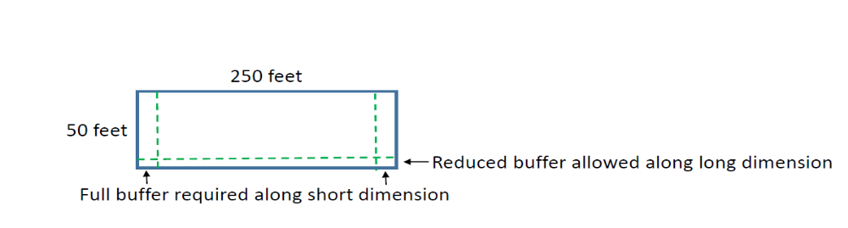
Figure 1216-F

(h) The following are exemptions from the Adjacent Use Buffer requirements.
(1) Bona fide agricultural operations.
(2) Land within the boundaries of an airport.
(3) Construction of an addition to an existing building, or construction of an ancillary building, that:
(i) is no closer to the adjacent lot than 50 feet;
(ii) is cumulatively less than 50% footprint increase; or
(iii) requires construction of less than 5 parking spaces total.
(4) Unlighted sports fields enclosed by a fence, golf courses, cemeteries, turf parking areas.
(5) Private recreational facilities constructed for use by the residents of a development when the facility is located in the interior of the development.
(6) Property which is separated from the adjacent property by a retention or other surface waterbody, greenbelt, drainage facility, or combination thereof, that would create a buffer of 100 feet or more in depth.
(7) Buildings and structures lawfully existing as of June 1, 2019, may be modernized, altered, or repaired without providing or modifying landscaping and buffers in conformance with this Part, provided there is no increase in the footprint of such building or structure or impervious area on the site greater than 50%.
(8) Single family detached, or two family attached dwellings on a single lot or parcel. However, if part of a residential subdivision, landscaping requirements for the lots still apply. For residential subdivisions of 3 or more lots, the buffer and screening requirements shall apply along the exterior of the subdivision.
(9) Whenever application of the strict requirements of this section to the renovation, restoration, reuse, or rehabilitation of property developed prior to June 1, 2019 will result in the loss of other site improvements required by this Code, the Director or designee may approve a site specific buffer plan which best meets the purpose and intent of these buffer requirements.
(i) Standards for Adjacent Use Buffers, screening and landscaping.
(1) Walls or fences shall be not less than 6 feet in height as measured from the finished grade of the project site, not from the bottom of a rear swale.
(2) All trees and shrubs must be placed on the exterior side of the wall as related to the new development, except as stated herein.
(3) All Adjacent Use Buffer areas shall be owned and maintained as common area by an HOA or similar, not individual single family residential lot owners. The separate parcel indicating the depth and ownership of the Buffer must be shown on the plat or provided to the City through a conservation easement, however the City shall not be required to maintain said easement.
(4) Walls must be constructed to ensure that historic water flow patterns are accommodated and all stormwater from the site is directed to on-site detention/retention areas in accordance with the SJRWMD requirements.
(5) Berms or Earth mounds may be used instead of fences or walls, but they shall not exceed a slope of three to one, and must still reach the height of 6 feet and be approved by the Director.
(6) Fences may be constructed of wood, vinyl or plastic.
(7) Use of Adjacent Use Buffer areas. Required buffers may be used for recreation and count toward required active recreation space if uses such as pedestrian, bike or equestrian trails are included, provided that:
(i) no required trees or shrubs are eliminated;
(ii) not more than 20% of the width of the Buffer is impervious surface;
(iii) The Buffer width is increased to a minimum of 20 feet and there is a minimum 15 foot wide landscape Adjacent Use Buffer and screen on the outside of the path(closest to the adjacent parcel); and
(iv) all other requirements of this Part are met.
(9) Grass or other ground cover shall be planted on all areas of the Buffer required by this Section which are not occupied by other landscape material.
(10) The Buffer shall not be used for principle or accessory uses and structures, VUAs , dumpster pads, signs, equipment, storage. Slopes within Buffers shall not exceed four to one.
(11) If a water body exists along the common property line between uncomplementary uses which is less than 100 feet wide when measured perpendicular to the property line then the Buffer shall be established between the use and the water body. Preserve areas may be used as Buffers, so long as the tree and visual landscape screen requirements can be satisfied.
* * *
Sec. 656.1222. - Buffer Street buffer requirements for residential subdivisions.
* * *
(d) Platting, maintenance, and open space credit. The buffer area and any additional screening shall be recorded on the plat and may be part of a lot or a separate tract. If part of a lot, the buffer area and any additional screening shall be maintained by the lot owner. If part of a separate tract, the buffer area and any additional screening shall be maintained by the homeowners' association in perpetuity. If the buffer area and additional screening is recorded as a separate tract on the plat then the site shall receive the equivalent area as a credit towards meeting recreation and open space requirements, not to exceed 25% of the required recreation and open space requirement.
(e) Removal of trees in required buffer. Trees within the required buffer area may be removed, subject to the permit requirements of Section 656.1206, Ordinance Code. Trees mitigated removed within the buffer shall be replaced within the buffer. At least one tree, a minimum of four inches DBH, shall be planted or preserved every 40 feet on center along perimeters of the site which are adjacent to roadways. If trees cannot be planted every 40 feet because of conditions including, but not limited to, drainage easements, the Chief may approve an alternative visual screen, consistent with subsection (c) regardless of the classification of the abutting right-of-way.
(f) Improvements permitted in buffer. . No new structures, impervious surfaces, unpaved vehicular use areas VUAs or other improvements shall be constructed within the designated buffer area other than fences, gates, mailboxes, necessary driveways, necessary sidewalks, and permitted signs.
* * *
Section 2. Directive to the codifiers. The codifiers are directed to re-arrange the Definitions in Section 656.1203 so that the defined words are placed in alphabetical order.
Section 3. Enforcement Dates. If a 10-set for a development has been submitted for review either prior to the Effective Date of this ordinance, or within thirty (30) days thereafter, the previous requirements of the Code shall be applied.
Section 4. Effective Date. This Ordinance shall become effective upon signature by the Mayor or upon becoming effective without the Mayor’s signature.

Form Approved:

/s/ Susan C. Grandin_____
Office of General Counsel
Legislation Prepared By: Susan C. Grandin
0000.doc

